**Executive Summary**

The goal of this report and project was to develop a math model to forecast the evolution of a plant ecosystem over time under the influence of erratic weather patterns, incorporating periods of drought and differing precipitation conditions. A Python program was chosen as it can simulate the germination and harvest of kernels under various weather conditions which is essential for agricultural research and planning. The model aims to provide insights into kernel viability, biomass growth, and environmental impact during the growth cycle.

Plant species exhibit diverse responses to environmental stresses, with each species reacting uniquely to specific conditions. Traditional agricultural practices often rely on empirical knowledge and experience to predict crop yields. However, with the advancement of technology, computational models offer a more systematic approach to understand and forecast crop behavior. This math model uses a python program to integrate weather patterns, seed biology, and environmental factors to simulate the germination and growth of corn kernels.

The primary objective of this project is to create a flexible and accurate Python model that can simulate the germination and harvest process for corn kernels and crops under different weather conditions. The model should provide valuable insights into seed viability, biomass production, and environmental impact. This report investigates the potential benefits of companion planting to combat the effects of irregular weather patterns on corn biomass yield in Minnesota. A Monte Carlo simulation model was developed to simulate corn growth under varying temperature and precipitation conditions. The impact of companion plants was also added.

The project began by defining variables, parameters, and lists necessary for the simulation. Weather conditions conducive to germination were specified, and a random selection mechanism was implemented to mimic real-world variability. A simulation loop was initiated to conduct multiple trials, each representing a growing season. Within each trial, germination conditions were evaluated, and viable seeds were recorded. Subsequently, seeds could grow into biomass, with germination rates calculated for analysis. During the harvest season, environmental impact parameters were considered, and biomass growth was adjusted accordingly. Daily mean temperature and precipitation values were calculated to monitor environmental conditions throughout the growth cycle. The model generated comprehensive data sets capturing initial and final biomass, germination rates, and environmental parameters for further analysis.

The findings suggest that companion planting with crops like squash or beans (impact value > 0) might increase seasonal yield when compared to monoculture corn. However, further research is needed to explore the specific effects of different companion plant species.

The model itself incurs minimal costs as it is implemented in Python, a freely available open-source programming language. However, the real-world applications of the model may have cost implications, particularly in terms of data acquisition, computational resources, and potential adjustments in agricultural practices based on model insights.

Utilizing compatible companion plants, such as beans or squash, alongside main crops like corn, is advised to enhance biomass production. It is recommended to steer clear of companion plants known to exert adverse effects, prompting a need for additional investigation into such detrimental interactions. Furthermore, prioritizing companion plants resilient to drought and/or flooding, alongside selecting corn varieties with drought resistance, can bolster the resilience of the agricultural system to environmental stresses.

In conclusion, the Python model developed for simulating seed germination and harvest provides a valuable tool for understanding the complex dynamics of agricultural systems. By incorporating weather patterns, seed biology, and environmental factors, the model offers insights that can inform decision-making processes and contribute to sustainable agricultural practices.

**Introduction**

Drought can have a significant impact on crops, leading to lower biomass output. Companion crops are sometimes used to mitigate these effects. We will examine drought effects on biomass output and whether companion plants improve biomass output despite drought conditions. The model was assembled as follows.

1. A Python model was selected.
2. Weather pattern data was acquired.
3. Plant growth details were acquired.
4. Assumptions regarding soil, irrigation, and fertilization were determined.
5. Parameters were determined.
6. Programming model coded in Python.
7. Python was used to obtain weather effect results.

**Methods**

**Model Selection**

A Monte Carlo simulation was chosen to address the uncertainty and impact factors on corps' biomass. The analysis is deployed a Monte Carlo simulation approach due to its suitability for capturing the uncertainty and variability characteristic effect on corps’ biomass. According to Kenton (2023) from Investopedia, Monte Carlo simulations facilitate the examination of outcomes across diverse scenarios through repetitive sampling from probability distributions. So, this method offers a comprehensive framework for evaluating how weather conditions and environment impact on corn’s biomass.

**Formulation Of Model**

**Statement Problem**

The problem statement for the report concerns the exploration of companion planting as a strategic approach to mitigate the adverse effects of irregular weather patterns on corn biomass yield in Minnesota. Specifically, the study uses a Monte Carlo simulation model to examine how the introduction of companion plants, such as squash or beans, might affect the seasonal yield of corn when contrasted with traditional monoculture practices. The aim is to assess whether companion planting can effectively increase biomass output despite the challenges posed by drought and other variable weather conditions. This approach seeks to provide a robust analysis by simulating various environmental scenarios to determine the potential benefits and limitations of integrating companion plants into corn cultivation. The goal is to inform better agricultural practices that enhance yield stability and productivity in the face of climatic unpredictability.

Givens:

* Planting area = 1 acre.
* 1,000 seeds/kernels per acre.

**Assumptions**

The following assumptions were used in the model.

* Soil conditions are the same for each trial for the purposes of this analysis.
* No fertilizer used.
* No irrigation of plants is provided during growing season.
* No damage from pests is factored into the model.
* No (plant) disease
* Only daytime growth documented – no accounting for night conditions
* Germination temperature changes daily
* Uniform Distribution of germination times, soil temperature, and precipitation
* Exponential Distribution of kernel loss, implying that higher losses are less likely but possible.
* Germination only occurs if the soil temperature on the first day is above 55°F and other conditions within specified ranges are met.
* Germination period was randomized between 7 and 21 days.
* Soil temperature for germination was randomized between 60- and 90-degrees Fahrenheit.
* Kernel loss index of 6%.
* Biomass growth and loss are influenced by simple linear factors depending on temperature and precipitation conditions

**Parameters**

Germination Parameters:

* $$K_{i}$$: Initial Kernel (Corn Kernels / Acre)

**Variables**

Germination Variables:

* r: Germination Rate
* n: Number of Germinated Plants
* $$G_{b}$$: Germination Biomass

Variables for Biomass and Growth:

* g: Growth Factor
* e: Environment Factor
* c: Competition Factor
* $$B_{g}$$: Daily Biomass
* $$B_{n −1}$$: Previous Day Biomass

**Mathematical Equation**

The mathematical framework of our Monte Carlo simulation model involves several key variables and equations:

* Germination Rate:
  + r: n/k_i
* Germination Biomass
  + $$G_{b}$$ = 200n/1000
  + Where germination biomass is total germinated plants x 220 grams per plant divided by 1000 to give the kg
* Growth Factor
  + g: (1 – e) (1-c)
* Daily Biomass
  + $$B_{g}$$: $$B_{n −1}$$ (g)

**Detailed Discussion of Model Analysis**

**Applications Used for Computation**

The simulation was conducted using Python, known for its strong capabilities in data analysis and mathematical modeling. Key libraries such as "SciPy" were used for generating random variables with normal, exponential, and uniform distributions, while "pandas" facilitated data handling and analysis. Python's flexibility allowed for complex simulations of drought conditions and companion plant effects, with the ability to randomize multiple variables like precipitation and temperature across numerous trials.

**Key Algorithms and Calculations and Statistical Analysis**

**Germination**

The simulation employs a series of statistical and probabilistic algorithms to model the complex process of corn kernel germination and growth under variable weather conditions. Initially, kernel loss is simulated using an exponential distribution “**expon.rvs()**”, generating random kernel loss percentages to represent natural losses due to seed dormancy, endodormancy in particular. Following this, the germination periods for each viable kernel are randomized using a uniform distribution “**uniform.rvs()**”, adhering to specified minimum and maximum germination days. Concurrently, daily temperature and precipitation values are also randomly generated for each day of the germination period based on the parameters set by instances of the Condition class, reflecting different weather conditions.

The simulation then assesses germination success by checking if each kernel meets the required initial and median temperature, as well as median precipitation conditions, and records the germination times for kernels that successfully germinate. Post this evaluation, the number of successfully germinated kernels is adjusted according to the temperature and precipitation factors associated with the current weather condition. To introduce variability and realism into the simulation outcomes, a subset of these adjusted successful germinations is randomly selected. This sequence of steps ensures a realistic simulation of agricultural processes, accounting for both environmental variability and biological growth factors.

The statistical analyses integrated into the simulation are pivotal for understanding the germination dynamics of corn kernels under varying environmental conditions. The mean germination time is calculated using the “**statistics.mean()**” function, applied to the subset of kernels that successfully germinated after adjustments for temperature and precipitation factors. This provides an average measure of the time taken for kernels to germinate under specific conditions. Additionally, the germination rate is determined by calculating the ratio of germinated plants to the initial number of kernels, offering insight into the efficiency of germination per simulation.

Further, the biomass of germinated plants is computed, assuming each plant contributes a fixed amount of biomass (220 grams per plant), which is essential for estimating potential yield. The median daily temperature and precipitation, crucial factors for germination, are calculated using the “**statistics.median()**” function. This is done for the subset of days until germination for each kernel, ensuring that only those conditions suitable for germination are considered.

Moreover, the simulation utilizes a variety of statistical distributions to model different stochastic processes. Exponential distributions are used for simulating kernel loss, uniform distributions for generating random germination periods and daily weather conditions, and random choice distributions “**np.random.choice()**” for selecting subsets of successfully germinated kernels after adjustments.

***Biomass and Growth***

The simulation of the growth of corn biomass over a growing season is integrating a series of systematic processes and statistical methodologies. Initially, it sets the stage by initializing the biomass based on germination outcomes and defining temperature ranges alongside environmental impact constants that critically influence plant growth under varying daily weather conditions. To simulate realistic weather patterns, the code generates daily temperatures and precipitation using statistical distributions; temperatures are modeled with a normal distribution to encapsulate average conditions and their natural variability, while precipitation is derived from a uniform distribution, ensuring coverage of the full range of potential daily values.

Each day, the simulation assesses the combination of temperature and precipitation against set thresholds to ascertain an environmental impact factor. This factor, whether enhancing or reducing, adjusts the biomass in reflection of real-world scenarios like temperature extremes and fluctuating moisture levels. The daily adjusted biomass is computed by applying the identified growth or reduction factor to the biomass from the previous day, thus illustrating the accumulative impact of daily weather conditions on plant development.

As the growing season concludes, the code performs a comprehensive collection of data, including final biomass, average daily temperature, and precipitation, preparing these statistics for further analysis.

**Results**

Using a companion plant with a -0.2 impact, final biomass was only slightly higher than growing only the main crop. However, using a companion plant with a +0.2 impact, biomass yield was increased by 3.2%.

Figure 1: Competition Plant Impact Vs. Biomass (Kg)

Based on Figure 2, there is a strong correlation of daily temperature and precipitation on biomass with minimum temperature around 67c and maximum temperature around 73c. Its minimum precipitation is around 1.6 and its maximum precipitation is around 2.5. 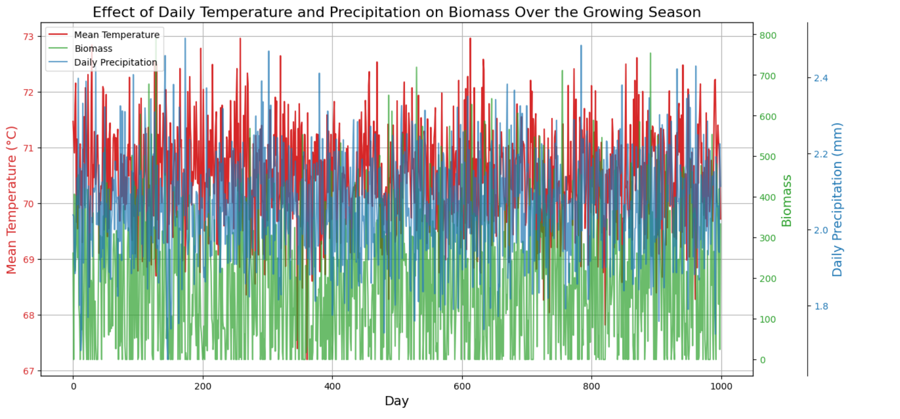Figure 2: Impact of Daily Temperature and Precipitation on Biomass

**Conclusion**

This project's purpose was to determine if companion plants would help offset drought effects and increase crop biomass. This model indicates that choosing companion plants with positive impacts will increase biomass by approximately 3%. The model can be expanded to include more than one companion plant to determine combinations that could prove to provide even more biomass increase.

**Recommendations**

It is recommended to include companion plants, such as beans or squash, with corn crops in order to increase total crop biomass. However, tomatoes are known to have a negative impact and should not be used as a companion for corn crops.

**References**

Kenton, W. (2023). *Monte Carlo Simulation: History, how it works, and 4 key steps*. Investopedia. https://www.investopedia.com/terms/m/montecarlosimulation.asp#:~:text=A%20Monte%20Carlo%20sim ulation%20is,impact%20of%20risk%20and%20uncertainty

.